UNIT-II
Introducing Deep Learning:
Biological and Machine Vision, Human and Machine Language, Artificial Neural Networks, Training Deep Networks, Improving Deep Networks.

Machine vision is the ability of a computer to see; it employs one or more video cameras, analog-to-digital conversion (ADC) and digital signal processing (DSP). The resulting data goes to a computer or robot controller. Machine vision is similar in complexity to voice recognition.
Machine vision is sometimes conflated with the term computer vision. The technology is often integrated with artificial intelligence (AI), machine learning and deep learning to accelerate image processing.

How does machine vision work?
Machine vision uses cameras to capture visual information from the surrounding environment. It then processes the images using a combination of hardware and software and prepares the information for use in various applications. Machine vision technology often uses specialized optics to acquire images. This approach lets certain characteristics of the image be processed, analyzed and measured.
For example, a machine vision application as part of a manufacturing system can be used to analyze a certain characteristic of a part being manufactured on an assembly line. It could determine if the part meets quality criteria and, if not, dispose of the part.
In manufacturing settings, machine vision systems typically need the following:
- Lighting. Lighting illuminates the object or scene to make its features visible.
- Lens. This captures the image and delivers it to the sensor in the camera as light.
- Capture board, frame grabber or sensor. These devices work together to process the image from the camera and convert it to a digital format as pixels. Image sensors convert light into electric signals using either complementary metal-oxide semiconductor technology or a charge-coupled device.
- Processor. The processor runs software and related algorithms that process the digital image and extracts the required information.
- Communication. These systems enable the machine vision cameras and processing system to communicate with other elements of the bigger system, usually using a discrete input/output signal or a serial connection.
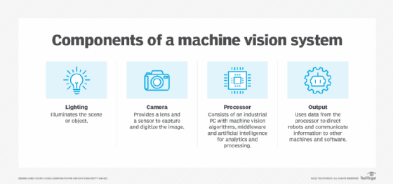Cameras and sensors are used to collect images as light or photons and turn them into electric signals or electrons for processing and use in industrial applications.
There are two types of cameras used in manufacturing machine vision: area scan cameras and line scan cameras. Here's how they work:
- Area scan. These cameras take pictures in a single frame using a rectangular sensor. The number of pixels in the sensor corresponds to the width and height of the image. Area scan cameras are used for scanning objects that are the same size in terms of width and height.
- Line scan. These cameras build an image pixel by pixel. They are suited for taking images of items in motion or of irregular sizes. The sensor passes in a linear motion over an object when taking the picture. Line scan cameras are not as limited to specific resolution the way area scan cameras are.
Camera lenses vary in optical quality. Two important specifications in any vision system are the sensitivity and the resolution of the lens, which have the following characteristics:
- Sensitivity is the ability of a machine to see in dim light or to detect weak impulses at invisible wavelengths.
- Resolution is the extent to which a machine can differentiate between objects.
In general, the greater the resolution, the more confined the field of vision. Sensitivity and resolution are interdependent. If other factors are constant, increasing the sensitivity reduces the resolution, and increasing the resolution reduces the sensitivity.
Human eyes are sensitive to electromagnetic wavelengths ranging from 390 to 770 nanometers. Video cameras can be sensitive to a range of wavelengths much wider than that. Some machine vision systems function at infrared, ultraviolet or X-ray wavelengths.
Binocular, also called stereo, machine vision requires a computer with an advanced processor. In addition, high-resolution cameras, a large amount of RAM and AI programming are required for depth perception.

How are machine vision systems used?
Machine vision applications are used in a range of industries to perform various tasks, including the following:
- Electronic component analysis. Machine vision is used in the construction of circuit boards for tasks such as solder paste inspection and component placement.
- Optical character recognition. OCR enables a computer to extract printed or handwritten text from images.
- Handwriting and signature recognition. With these features, a computer can detect patterns in images of handwriting and signatures.
- Object recognition. In the automotive industry, self-driving cars use object recognition on images taken by cameras to identify obstacles on the road. Machine vision systems also determine the position of objects, such as the proper placement of a label on a pill bottle.
- Pattern recognition. Medical imaging analysis uses pattern recognition to make diagnoses based on technologies such as magnetic resonance imaging, blood scans and brain scans.
- Materials inspection. Machine vision capabilities in materials inspection systems ensure quality control. Machine vision checks for flaws, defects and contaminants in a range of materials and products. For example, these systems can inspect pills and tablets for issues during manufacture.
- Currency inspection. Machine vision is used to analyze currencies to detect counterfeit notes.
- Item counting. This capability is used to tally items such as pills in a packet or bottles in a case.

Machine vision in AI
AI is used in machine vision to expedite the decision-making process. AI is able to process a large amount of images and data information that was previously too difficult to gather.
Examples of how AI is used with machine vision are the following:
- Signature and character recognition require a level of nuance that AI can assist with.
- In manufacturing, AI helps with object recognition and materials inspection to enable machine vision systems to understand acceptable variations in the shape and texture of an object or material.
- In quality assurance, an AI-enabled system can interpret acceptable anomalies rather than rejecting anything that doesn't rigidly fit one specification.
- Artificial Neural Network Tutorial provides basic and advanced concepts of ANNs. Our Artificial Neural Network tutorial is developed for beginners as well as professions.
- The term "Artificial neural network" refers to a biologically inspired sub-field of artificial intelligence modeled after the brain. An Artificial neural network is usually a computational network based on biological neural networks that construct the structure of the human brain. Similar to a human brain has neurons interconnected to each other, artificial neural networks also have neurons that are linked to each other in various layers of the networks. These neurons are known as nodes.
- Artificial neural network tutorial covers all the aspects related to the artificial neural network. In this tutorial, we will discuss ANNs, Adaptive resonance theory, Kohonen self-organizing map, Building blocks, unsupervised learning, Genetic algorithm, etc.

What is Artificial Neural Network?
- The term "Artificial Neural Network" is derived from Biological neural networks that develop the structure of a human brain. Similar to the human brain that has neurons interconnected to one another, artificial neural networks also have neurons that are interconnected to one another in various layers of the networks. These neurons are known as nodes.
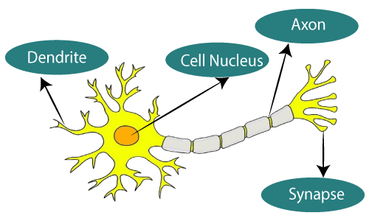The given figure illustrates the typical diagram of Biological Neural Network.
The typical Artificial Neural Network looks something like the given figure.
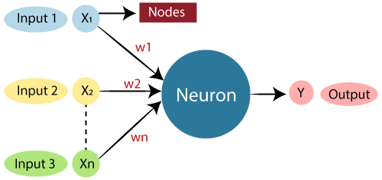
Dendrites from Biological Neural Network represent inputs in Artificial Neural Networks, cell nucleus represents Nodes, synapse represents Weights, and Axon represents Output.
Relationship between Biological neural network and artificial neural network:
Biological Neural Network | Artificial Neural Network
Dendrites | Inputs
Cell nucleus | Nodes
Synapse | Weights
Axon | Output
An Artificial Neural Network in the field of Artificial intelligence where it attempts to mimic the network of neurons makes up a human brain so that computers will have an option to understand things and make decisions in a human-like manner. The artificial neural network is designed by programming computers to behave simply like interconnected brain cells.
There are around 1000 billion neurons in the human brain. Each neuron has an association point somewhere in the range of 1,000 and 100,000. In the human brain, data is stored in such a manner as to be distributed, and we can extract more than one piece of this data when necessary from our memory parallelly. We can say that the human brain is made up of incredibly amazing parallel processors.
We can understand the artificial neural network with an example, consider an example of a digital logic gate that takes an input and gives an output. "OR" gate, which takes two inputs. If one or both the inputs are "On," then we get "On" in output. If both the inputs are "Off," then we get "Off" in output. Here the output depends upon input. Our brain does not perform the same task. The outputs to inputs relationship keep changing because of the neurons in our brain, which are "learning."

The architecture of an artificial neural network:
To understand the concept of the architecture of an artificial neural network, we have to understand what a neural network consists of. In order to define a neural network that consists of a large number of artificial neurons, which are termed units arranged in a sequence of layers. Lets us look at various types of layers available in an artificial neural network.
Artificial Neural Network primarily consists of three layers:
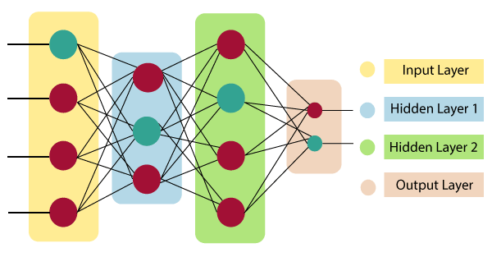
Input Layer:
As the name suggests, it accepts inputs in several different formats provided by the programmer.
Hidden Layer:
The hidden layer presents in-between input and output layers. It performs all the calculations to find hidden features and patterns.
Output Layer:
The input goes through a series of transformations using the hidden layer, which finally results in output that is conveyed using this layer.
The artificial neural network takes input and computes the weighted sum of the inputs and includes a bias. This computation is represented in the form of a transfer function.
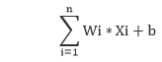
It determines weighted total is passed as an input to an activation function to produce the output. Activation functions choose whether a node should fire or not. Only those who are fired make it to the output layer. There are distinctive activation functions available that can be applied upon the sort of task we are performing.

Advantages of Artificial Neural Network (ANN)
Parallel processing capability:
Artificial neural networks have a numerical value that can perform more than one task simultaneously.
Storing data on the entire network:
Data that is used in traditional programming is stored on the whole network, not on a database. The disappearance of a couple of pieces of data in one place doesn't prevent the network from working.
Capability to work with incomplete knowledge:
After ANN training, the information may produce output even with inadequate data. The loss of performance here relies upon the significance of missing data.
Having a memory distribution:
For ANN is to be able to adapt, it is important to determine the examples and to encourage the network according to the desired output by demonstrating these examples to the network. The succession of the network is directly proportional to the chosen instances, and if the event can't appear to the network in all its aspects, it can produce false output.
Having fault tolerance:
Extortion of one or more cells of ANN does not prohibit it from generating output, and this feature makes the network fault-tolerance.

Disadvantages of Artificial Neural Network:
Assurance of proper network structure:
There is no particular guideline for determining the structure of artificial neural networks. The appropriate network structure is accomplished through experience, trial, and error.
Unrecognized behavior of the network:
It is the most significant issue of ANN. When ANN produces a testing solution, it does not provide insight concerning why and how. It decreases trust in the network.
Hardware dependence:
Artificial neural networks need processors with parallel processing power, as per their structure. Therefore, the realization of the equipment is dependent.
Difficulty of showing the issue to the network:
ANNs can work with numerical data. Problems must be converted into numerical values before being introduced to ANN. The presentation mechanism to be resolved here will directly impact the performance of the network. It relies on the user's abilities.
The duration of the network is unknown:
The network is reduced to a specific value of the error, and this value does not give us optimum results.
Science artificial neural networks that have stepped into the world in the mid-20th century are exponentially developing. In the present time, we have investigated the pros of artificial neural networks and the issues encountered in the course of their utilization. It should not be overlooked that the cons of ANN networks, which are a flourishing science branch, are eliminated individually, and their pros are increasing day by day. It means that artificial neural networks will turn into an irreplaceable part of our lives progressively important.

How do artificial neural networks work?
Artificial Neural Network can be best represented as a weighted directed graph, where the artificial neurons form the nodes. The association between the neurons outputs and neuron inputs can be viewed as the directed edges with weights. The Artificial Neural Network receives the input signal from the external source in the form of a pattern and image in the form of a vector. These inputs are then mathematically assigned by the notations x(n) for every n number of inputs.
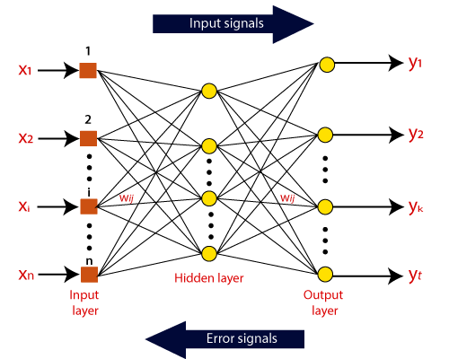

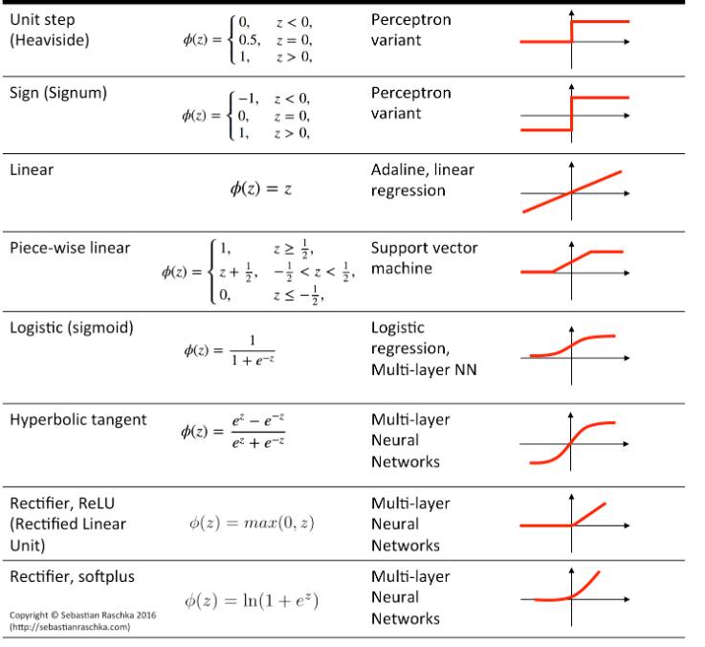

Sigmoid Activation Function
Formula: σ(x)=11+e−x\sigma(x) = \frac{1}{1 + e^{-x}}σ(x)=1+e−x1​

Features
- Outputs value between 0 and 1
- Smooth and differentiable
- Historically used in early neural networks

Applications
- Binary classification (output layer)
- Logistic regression models
- Probabilistic interpretation (gives probability score)
- When output must lie between 0–1

Tanh (Hyperbolic Tangent) Function
Formula: tanh⁡(x)=ex−e−xex+e−x\tanh(x) = \frac{e^x - e^{-x}}{e^x + e^{-x}}tanh(x)=ex+e−xex−e−x​

Features
- Output range –1 to +1
- Zero-centered, faster convergence than sigmoid

Applications
- Hidden layers in older neural network models
- RNNs (earlier architectures)
- Situations where negative output is needed

ReLU (Rectified Linear Unit)
Formula: f(x)=max⁡(0,x)f(x) = \max(0, x)f(x)=max(0,x)

Features
- Simple, very fast
- Solves vanishing gradient problem partially
- Most commonly used in deep learning today

Applications
- CNNs for image tasks
- Deep feedforward networks
- NLP deep models
- Any modern deep neural architectures
(Because it trains faster)

Leaky ReLU
Formula:
f(x)=xf(x) = xf(x)=x if x>0x>0x>0
f(x)=0.01xf(x) = 0.01xf(x)=0.01x if x<0x<0x<0

Features
- Fixes "ReLU dying neuron" problem
- Allows small gradient for negative values

Applications
- Deep CNNs and DNNs where ReLU neurons die
- Generative models (GANs)
- Tasks needing stable gradients

Softmax Activation

Features
- Converts outputs into class probabilities summing to 1

Applications
- Multiclass classification (output layer)
Example: digit recognition (0–9)
- NLP tasks: next-word prediction
- Any classification with more than two classes

